Project 3 Brief
BACH

Situation / Āhuatanga:
Waiopehu College is investing in a beachfront section at Foxton Beach. They are wanting to design a bach for teachers on the weekends. The bach needs to visually embrace the multi cultural population of people that will be using it. The designers need to consider this in their design.
The school currently has no design for the bach, and would like students to offer their ideas.

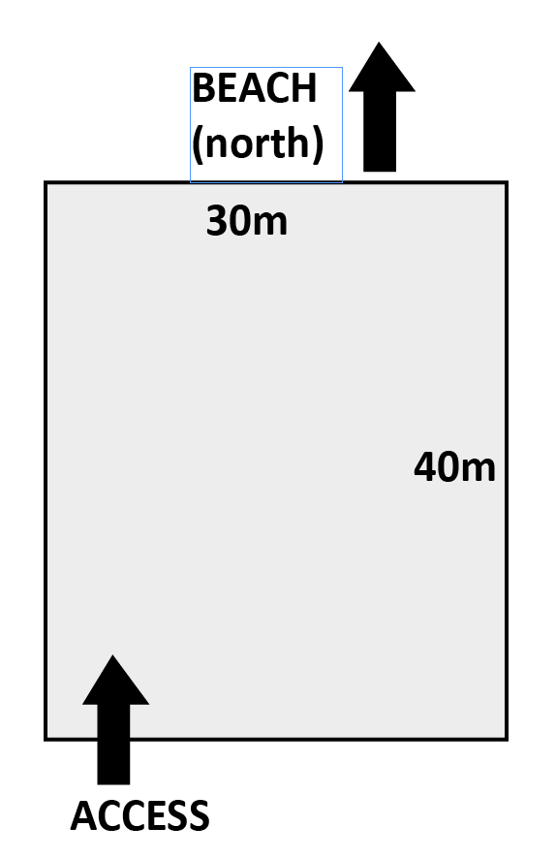
Design Specifications / Hoa whakatakoranga:
- The section is a rectangle sized 30m x 40m
- The section is North Facing – you will need to
research what this means
- The bach can have a footprint no larger than SITE PLAN
100 square meters
- There must be an external covered car park
- There must be a deck attached no larger than
8 square meters
- In the bach there must be a bathroom, toilet,
bedroom and open plan living space which
includes the kitchen and lounge
- The bach must show influence from your studied designer

Design Process:
Step One: Bach Research / Tirohanga:
This bach is a small space design. We will watch a George Clarkson small spaces in class and take visual sketch notes. Following this, you will use the Internet and magazines to create some research pages to help you gather ideas for your Bach space.

Research cultural houses (Marae, Fale etc) and take notes of the features that make them unique. You can add these features to your own design.

Step Two: Concepts / Ariā:

You will need at least 3x ideas for your bach floorplan. We will use 3x methods to create ideas for a floorplan:
- Gridding
- Blocks
- Bubble Diagrams

You will choose the most successful / interesting floorplan you have made and use this for your development.

Step Three: Development / Tupunga:

Using the floorplan you have chosen, you will need to develop it further based on comfort and light. Explore where the light comes from and how this effects the layout of your design.
- Consider placement of doors and windows – how does these fixtures effect the room?
- Look at the open plan style of your lounge / kitchen / dining area
- Look at your bathroom – can you make this more compact?
- Where can the carport go?
- How can you bring in some features of your designer?

Once you have finalised the layout and design of your bach you will need to set it up on Sketchup and look at the external cladding. You can use the paint bucket in Sketchup to use different textures.

Step Four: Final Design Images + Evaluation

When you have finished the sketchup model it is time to create a presentation to showcase the design!
2x A3 colour prints.
- 1x A3 of basic info + Interior Screenshots
- Title
- Brief
- Interior Screenshots
- 1x A3 page of Exterior screenshots

DUE: 28 OCTOBER 2016

TICK WHEN DONE | TASK | TICK WHEN DONE | TASK
 | Brainstorm |  | Developed floorplan
 | George Clarkson Small space video sketch notes |  | Sketchup developments - Exterior
 | Internet / magazine bach and designer research |  | Sketchup developments - Interior
 | Floorplan concept – Bubble diagrams |  | Final Sketchup model
 | Floorplan concept – Grids |  | Final Sketchup presentation
 | Floorplan concept – Blocks |  | Evaluation

